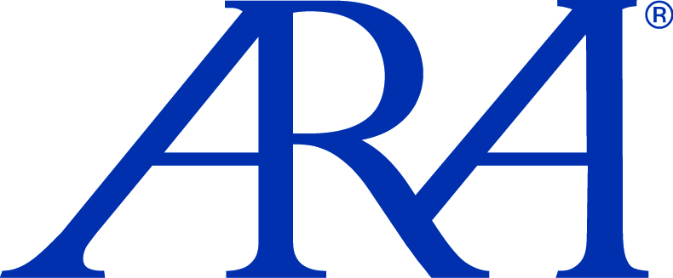

IN THE NEWS

FOR IMMEDIATE RELEASE

Local Contact: National Contacts:
Linda Dugo Amy Morris or Lisa Robinson
ARA Dallas ARA National
(972) 934-3400 (404) 495-7300
Linda.Dugo@ARAusa.com mailto:aholland@ARAusa.com
www.ARAusa.com lrobinson@ARAusa.com
www.ARAusa.com

ARA Dallas Recruits Land Specialist From Henry S. Miller Brokerage
Former Senior Vice President, Chris Colombe, Will Provide Land Brokerage Expertise

Dallas, TX (February 28, 2011) — Atlanta-headquartered ARA, the largest privately held, full-service investment advisory brokerage firm in the nation focusing exclusively on the multihousing industry, announced today that Chris Colombe has joined ARA’s Dallas, TX brokerage operations – under the leadership of Brian O'Boyle, Sr.

Colombe's focus will be on the sale of development sites and multi-family redevelopment opportunities. He brings a stellar track record of performance from his previous alliance with the Henry S. Miller Brokerage team, where he was Senior Vice President and a member of the Chairman's Council. While at Henry S. Miller, Colombe closed over $100M in property sales and achieved special recognition five times as one of Miller's "Top Ten Brokers" in the state of Texas.

Colombe said that he was interested in aligning his experience and success with an established team focusing exclusively in the multi-family arena. "ARA is known throughout the industry for their outstanding level of expertise in the sale of apartment projects. I hope to leverage off the ARA platform and provide our clients with a quality of service unmatched in the industry," said Colombe.

“We are pleased to add the exceptional talent of Chris Colombe to our roster," said O'Boyle, "as he is a seasoned veteran with a tremendous amount of experience and a long-term track record. The depth of his knowledge will only enhance our ability to continue to provide top-notch service to our clients."

To schedule an interview with an ARA executive regarding this release or for more information about ARA, please contact Lisa Robinson at lrobinson@ARAusa.com or 678.553.9360.

Contact Information:
Chris Colombe
Investment Sales
ARA Dallas
14114 Dallas Parkway, Suite 520
Dallas, TX 75254
214.420.3102 – direct
ccolombe@arausa.com

About ARA
Atlanta-headquartered ARA is the largest privately held, full-service investment advisory firm in the nation that focuses exclusively on the brokerage, financing and capital sourcing of multihousing properties including conventional, affordable, distressed assets, notes sales, seniors, student & manufactured housing and multihousing land. ARA is comprised of the country’s top investment professionals who leverage a unique and fully integrated cooperative business platform of shared information, relationships and technology driven solutions. ARA’s unified enterprise approach ensures that clients are delivered the broadest asset exposure, effective matching of buyers and sellers, and the shortest transaction timeframes in the industry. The combination of resources, unparalleled market expertise and nationwide presence in the multihousing marketplace has resulted in average annual production volume of $6.3 billion in real estate transactions since 2003. For detailed information on ARA’s extensive multihousing investment services, visit www.arausa.com.

